POSITION DESCRIPTION FORM – SURF LIFE SAVING WESTERN AUSTRALIA
Department: | Lifesaving
Position Title: | Operations Controller
Position Level: | N/A
Location: | 7 Delawney Street Balcatta, WA 6021
Main Purpose of Job: | The Operations Controller is the command, coordination, and communication representative for all SLSWA incident response. The role ensures appropriate SLSWA assets are mobilized in response to an incident, and liaises with Emergency Services in support of a joint public safety initiative. The position ensures complete, timely, and accurate information is communicated to all emergency stakeholders, evaluates the level of response required of internal and external emergency services, and maintains effective tasking of priority assets. Operations Controllers also assist with routine operational requirements, including fielding media enquiries, statistical reporting, and other administrative tasks.
Subordinate Staff: | Nil
Reporting To: | Support Operations Officer

Department Structure and Relationships

The Operations Controller position exists within the SLSWA Lifesaving Department and has a direct reporting relationship as per the structure below:

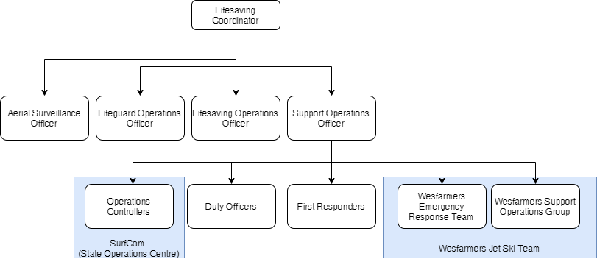

Position Description

The Operations Controller provides support to, and enacts guidance and direction from the Support Operations Officer in achieving the outcomes of the SLSWA Strategic and Operational Plan.

The Operations Controllers key functions and responsibilities in the command, coordination, and communication of deliverable service includes but is not limited to:

- Liaise with SLSWA services, council rangers, emergency services and other relevant parties.
- Provide relevant SLSWA staff with timely and accurate information.
- Effectively prioritize the coordination of multiple resources simultaneously in response to routine and emergency incidents SLSWA is involved in.
- Gather, assess and disseminate information including but not limited to, weather conditions and status of service levels to appropriate authorities.
- Affect relevant SLSWA policies and procedures in response to routine incidents through effective tasking of SLSWA resources.
- Monitor and operate the SLSWA’s Emergency Radio Communication Network (ERCN) and Beach Camera Network.
- Effectively communicate and document, utilising appropriate strategic prioritisation, a broad range of routine and emergency information via phone, radio, internet based platforms, and in person.
- Monitor the operational status and safety of all frontline SLSWA personnel and volunteers.
- Monitor the ERCN and MikroTik (‘DUDE alarm’) for communication network faults, and oversight of ‘in-field’ daily equipment checks, action and escalating as required.
- Actively liaise with the SLSWA and / or SLSA IT department regarding any communications or technology faults, which have the potential to negatively impact operations, through to resolution.
- Work collaboratively within the State Operations Centre and contribute toward the achievement of required performance targets and service delivery standards.
- Participate in individual and collective professional development opportunities as guided by the Support Operations Officer.
- Provide input toward the development and continuous improvement of policies and procedures for the effective service delivery of the State Operations Control Centre.
- Data entry of all relevant information and records, into the various databases including patrol logs, incident reports, along with any additional records as directed by the Support Operations Officer.
- Appropriately direct or respond to media enquiries in accordance with guidance from Support Operations Officer and SLSWA Media Department.
- Participate in performance improvement strategies as requested by Support Operations Officer.
- Assist in the provision of routine operational reports upon request of the Support Operations Officer and Lifesaving Coordinator.
- Assist the Support Operations Officer to review and assess event sanctioning applications prior to approval.
- Communicate and interact effectively, to build and sustain collaborative professional relationships as a well-disciplined member of the Operations Centre service delivery team.
- Demonstrate an awareness of people with diverse cultural backgrounds and undertake all available cross-cultural related training to ensure rapid and appropriate responses.
- Present fit for duty by being physically and psychologically healthy, illness and fatigue free, and proactively using staff support and counselling services when required.
- Attend meetings and training sessions as required by SLSWA.
- Assist with the delivery of corporate administrative functions as required.
- Promote teamwork, cooperation, and autonomy.

Behave with honesty, integrity and impartiality to maintain the positive reputation of SLSWA.

Carry out specific tasks as required by the Support Operations Officer, or delegate.
- Any other duties as required.

Position Deliverables
- All information is prioritised and actioned with in specified timeframes.
- Adherence to radio discipline.
- Participate in the continuous improvement of radio telecommunication procedures within SLSWA.
- All incidents receive appropriate level of support and resources.
- All logs, reports and data entered into the appropriate database systems accurately and within pre-set timeframes.
- A positive image of the individual is achieved and maintained at all times when on duty or attending SLSWA related events.
- Direction provided to SLSWA services is in accordance with SLSWA policies, procedures, ethics, and values.
- All SurfCom equipment is accounted for and remains in a serviceable condition.
- Actively participate in relevant training sessions and programs.
- Participate in reviews, and investigations as required.
- Specific tasks are actioned in a timely manner and completed to a satisfactory level.
- Participate in training initiatives to ensure competence.
- Any other duties as required.

Selection Criteria | Essential/ Desirable
Experience
- Previous experiencing as a member within small team  - Ability to respond appropriately under pressure, make sound judgement and determine task priorities. | Essential  Essential
- Ability to communicate to various stakeholders during emergency situations. | Essential
- Previous exposure to an operations center or executing operational command decisions. | Desirable
- Prior experience working as an Emergency Dispatch Officer or Surf Life Saving Operations Centre. | Desirable
- Experience and theoretical knowledge of surf lifesaving service delivery. | Desirable
- Current surf lifesaving Club membership. | Desirable
- An understanding of surf lifesaving procedures, practices and policies. | Desirable
- Lifesaving service/patrol experience. | Desirable
Skills
- Demonstrated computer literacy, specifically in the use of Microsoft Office, internet searches, and web-based databases. | Essential
- Very high verbal and written communications skills | Essential
- Well-developed interpersonal skills including active listening, assertiveness and empathy. | Essential
- Ability to negotiate with multiple stakeholders with conflicting priorities. | Essential
- Ability to work unsupervised as well as in a team environment. | Essential
- Ability to operate SLSWA ERCN and Beach Camera Network. | Desirable
• Marine Radio Operator’s VHF Certificate of Proficiency (MROVCP). | Desirable
Qualifications
• Current Provide First Aid – HLTAID003 or equivalent | Desirable
• Silver Medallion – Basic Beach Management. | Desirable
Special Requirements
• Flexible and able to work rostered hours which will include weekends and public holidays | Essential
• Integrity and trustworthiness | Essential
• High level of professionalism and composure under pressure | Essential
• Understanding of Occupational Health and Safety principles and practices | Desirable
• An understanding of risk management principles and practices | Desirable

Prepared by: Mick Owens | Approved by: Nick Pavy
Position title: Support Operations Officer | Position title: Lifesaving Coordinator
Date: July 2020 | Date: July 2020

